Grade 8 Review for Final – Unit 1
1) B 2) A 3) A 4) C 5) A 6) B 7) B 8) C 9) B 10) D 11) A 12) B
13) (Answers will vary) When I try to use whole numbers to make a square with an area of 49 I can with sides of 7 and 7. The closest to a square with area 24 I can come to with whole numbers is 4 by 6. This means 49 is a square number and 24 is not
4
6
7
7

14) 16.2cm 15) a) 196 b) 11 c) 34 16) 36cm
17) A Pythagorean triple is a set of three numbers a,b,c, where $a^{2}+b^{2}=c^{2}$.
Since ${30}^{2}+{40}^{2}={50}^{2}$ these numbers are a Pythagorean triple.
18) 15m
19) 225 has an odd number of factors so it is a square number, the middle factor 15 is the square root. 120 has an even number of factors so it is not a square number.
Grade 8 Review for Final – Unit 2
1) C 2) A 3) B 4) A 5) B 6) C 7) B 8) A 9) D 10) D 11) C
12) $\left(+2\right)\left(+4\right) \& \left(-3\right)\left(-6\right) \& \left(-3\right)\left(-5\right) \& (-5)(-6)$ 13) answers may vary
14) A) 6 B) -6 C) 6 15) $675
Grade 8 Review for Final – Unit 3
1) D 2) B 3) B 4) D 5) C 6) D 7) A 8) C 9) D 10) A 11) B
12) $1/2$ 13) a) $1/2$ b) $17/8$ 14) ${31}/{10}=31/{10}$ 15) ${12}/{13}$

Grade 8 Review for Final – Unit 4
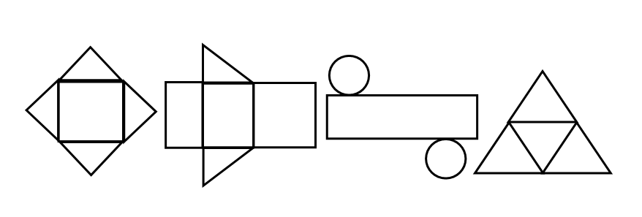
1) B 2) A 3) A 4) C 5) B 6) C 7) C 8) B
9)

Square Pyramid Triangular Prism Cylinder Tetrahedron
1 square 3 rectangles 1 rectangle 4 triangles
4 triangles 2 triangles 2 circles
10) 200cm³ 11) 390cm² 12) 2860mm³

Grade 8 Review for Final – Unit 5
1) C 2) D 3) A 4) A 5) C 6) A 7) B 8) B 9) C 10) D 11) B 12) C 13) B 14) C 15) C 16) A 17) D 18) C 19) B 20) B 21) B 22) B 23) C 24) C 25) B 26) C27) The 5kg of apples is better at $0.75 per kg 28) $3.23 29) 65% 30) 2 pieces 31) 46 32) a) $14.25 b) $80.73 c) $91.23 33) 432 35) 12 36) 28.6% 37)Crystal clear at $0.825 per bottle 38) a) $90 b) $209.99
Grade 8 Review for Final – Unit 6
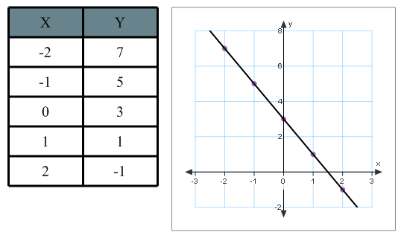
1) D 2) B 3) B 4) C 5) A 6) C 7) A 8) A 9) A 10) C 11) A 12) B 13) A
14) x = -4 15a) x = 36 15b) x = -9 16)
17) x = -4
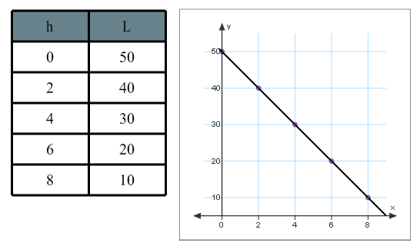
18) x = 2
19)

Grade 8 Review for Final – Unit 7
1) A 2) A 3) A 4) B 5) C 6) C 7) C 8) A 9) D 10) D 11) A 12) C 13) B
14a) $\frac{49}{400}$ 14b) $\frac{13}{100}$ 15a) Bar Graph 15b) See text page 385
16a)Attention is drawn towards COKE (25%) as the favorite, however, PEPSI (30%) is the actual favorite.
16b) The creator of the graph could possibly work for the company that produces COKE.
17a) $\frac{1}{8}$ 17b) $\frac{1}{2}$ 18) 9.75% 19a) See text page 385 19b) See text page 385
19c) The line graph exaggerates the differences in the number of late students each day.
19d) The circle graph shows how the number of late students was about the same each day.
20a) It gives the impression that Robbie has more cards.
20b) Robbie may have wanted to make it look like he has more cards.
20c) Use the same vertical scale for each graph.
21ai) $\frac{1}{9}$ 21aii) $\frac{1}{9}$ 22a) $\frac{1}{36}$ 22b) $\frac{8}{27}$ 22c) 0 22d) $\frac{1}{324}$

