Math 8 Chapter 8 Assignment Name: ______________
Part 1: Multiple Choice: Place the letter corresponding to the best response in the space provided.

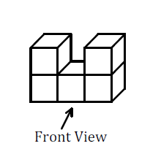
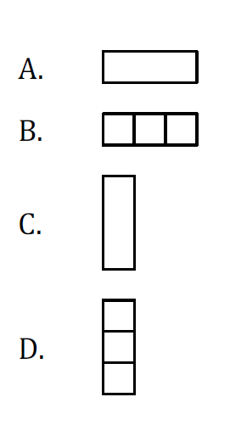
____1. What is the top view of the object?

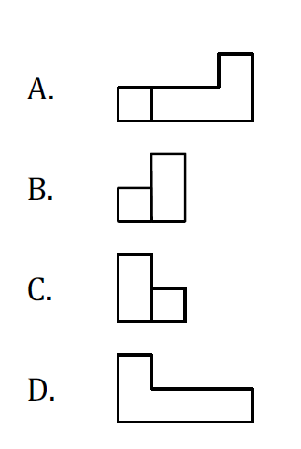
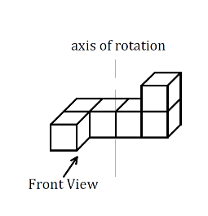
____2. What is the front view after this object is rotated horizontally 90$°$clockwise about the axis shown?

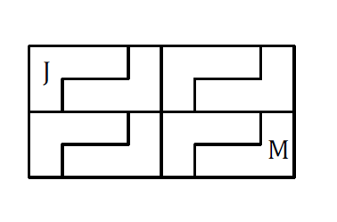
____3. Under what combination of transformations will Shape M be the image of Shape J?

A. reflection, rotation
B. reflection, translation
C. translation, reflection
D. translation, rotation

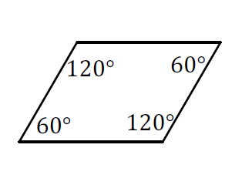
____4. If this polygon is tessellated, what is the sum of the angles where the vertices meet?

A. 90$°$
B. 180$°$
C. 270$°$
D. 360$°$

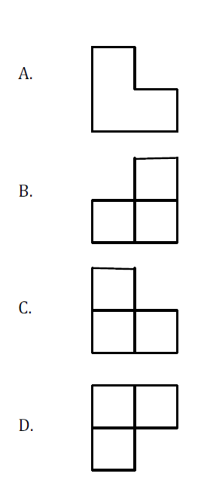
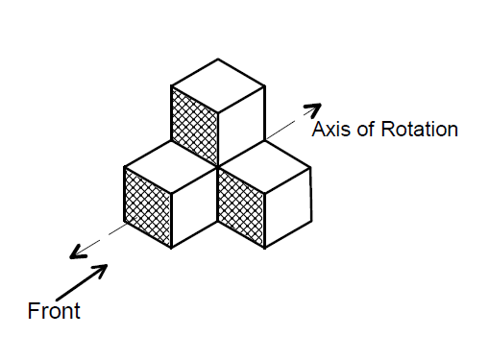
____5. Which is the front view of the object after it has been rotated 90o counter clockwise about the horizontal axis shown?

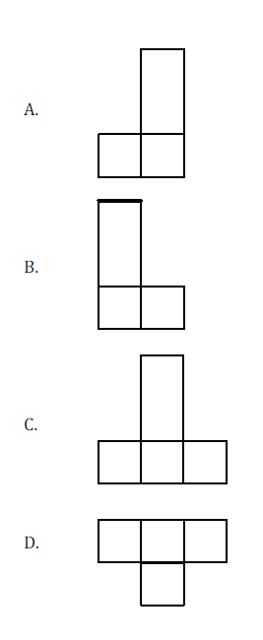
____6. Which is the left side view of the object after it has been rotated 180$°$ horizontally
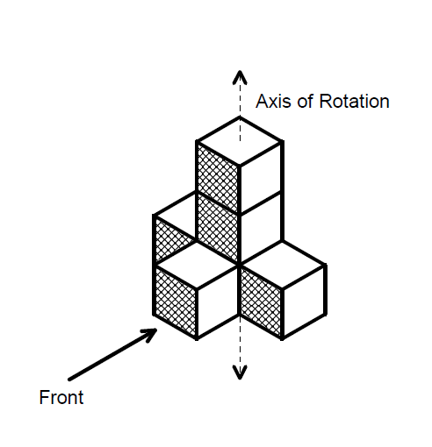
about the vertical axis shown?

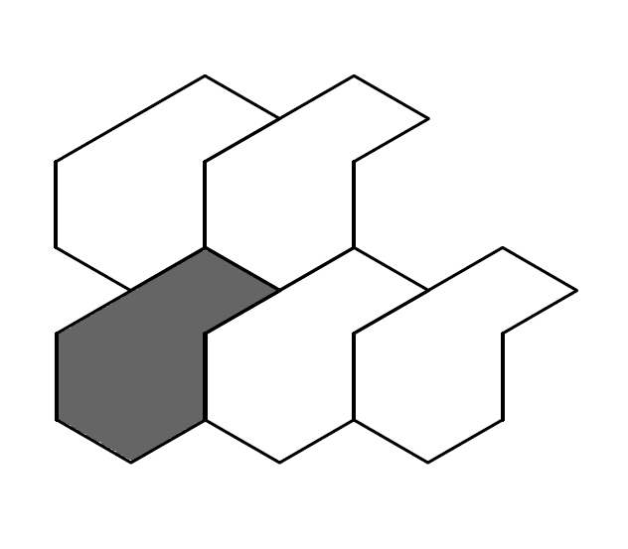
____7. What transformation forms this tessellation?

A. Dilatation
B. Reflection
C. Rotation
D. Translation

____8. Which represents the right side view of the object shown?

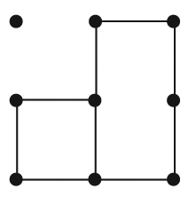
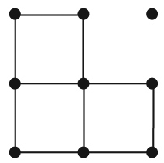
A) B)
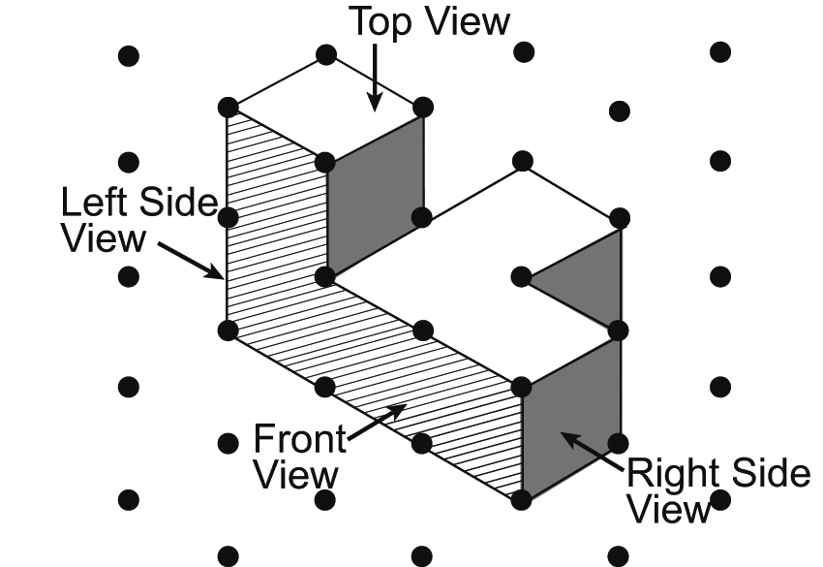

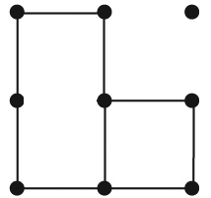
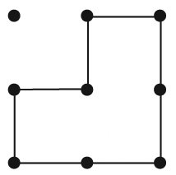
C) D)

____9. Which represents the top view of the object from question 8?
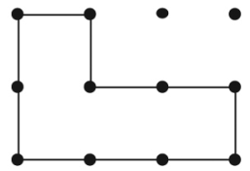
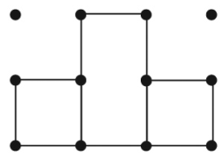
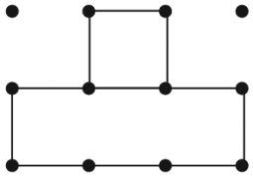
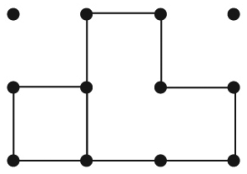
A) B) C) D)

____10 Which of these polygons tessellate?
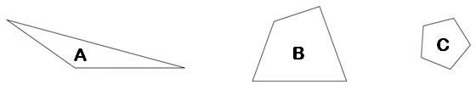

A) A only B) B only C) C only D) Both A and B
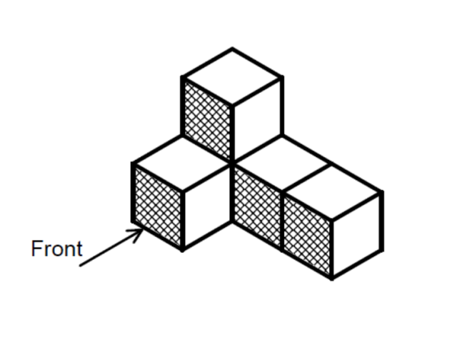

{4} 11. Sketch and label the front, top, left side and right side views of the object.

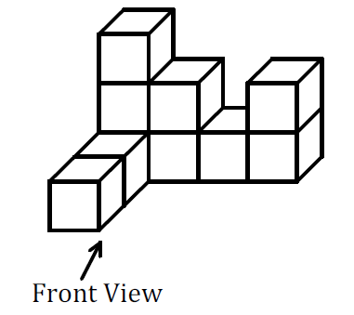
{4} 12. Draw the front, left, right, and top views of the object.
{4} 13. Use the shape to tessellate the space. What types of transformations did you use?
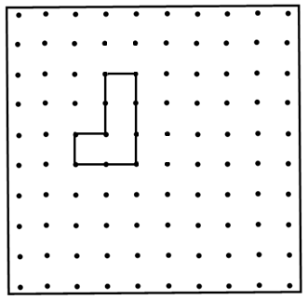

{3} 14. The shape shown will not tessellate as it is drawn. Without making a square, add to
this shape so that it will tessellate. Draw a picture of the new shape and sketch the
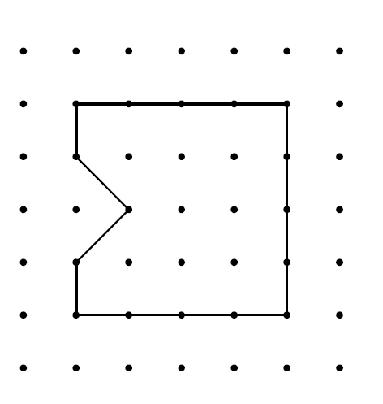
tessellation on the grid.

