**Grade Eight Review for Final – Unit 1**

**Multiple Choice Section**

1. Which diagram represents the perfect square, ?

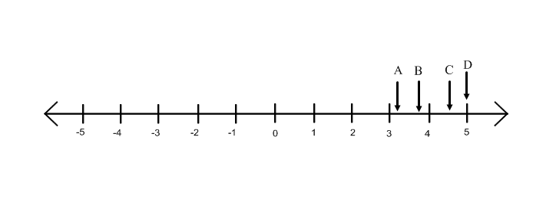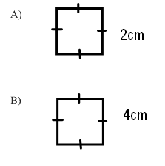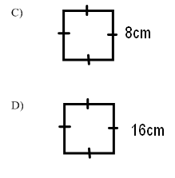

2. Which point on the number line corresponds to $\sqrt{10}$?

A) A

B) B

C) C

D) D

3. Which pair of whole numbers is $\sqrt{55}$ between?

1. 7 and 8
2. 8 and 9
3. 27 and 28
4. 54 and 55

4. Triangles are drawn with the following side lengths. Which will be a right triangle?

A) 5cm, 6cm 7cm

B) 5cm, 10cm, 14cm

C) 5cm, 12cm, 13cm

D) 5cm, 14cm, 16cm

5. If the dots are one centimetre apart, how long is

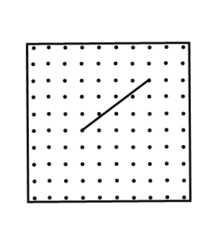the line segment?

A) 5cm

B) 7cm

C) 12.5cm

D) 25cm

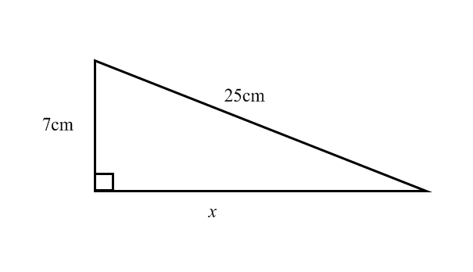

6. What is the value of ***x*** in the diagram?

A) 18cm

B) 24cm

C) 26cm

D) 32cm

7. Simplify:

A) 28

B) 59

C) 64

D) 99

8. What does equal?

A) 6

B) 12

C) 36

D) 324

9. In the diagram the triangle is a right triangle. What is the value of *x*?

*X*

16cm2

25cm2

A)

B)

C)

D)

10. Which of the following statements is **TRUE** ?

A) $\sqrt{5}$ is between 4 and 6.

B) $\sqrt{84}$ is equal to 42.

C) $\sqrt{4}+\sqrt{6}$ is equal to $\sqrt{10}$.

D) $\sqrt{82}$ is between 9 and 10.

11. Which number could you estimate the square root of using this model?



A) 5.5

B) 25

C) 30

D) 35

12. What is x to the nearest tenth of a centimetre?



A) 7.0

B) 12.1

C) 15.7

D) 21.0

**Long Answer Section**

13. Use a diagram to explain why 49 is a perfect square but 24 is not.

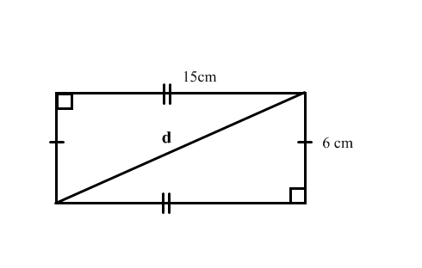

14. Find the length of the diagonal ***d*** to the nearest tenth.

15. Simplify.

a) 142 b)  c) 

16. The square to the right has an area of $81{cm}^{2}$, what is its perimeter?

17. Using mathematics and words explain why 30,40 and 50 are called a Pythagorean triple.

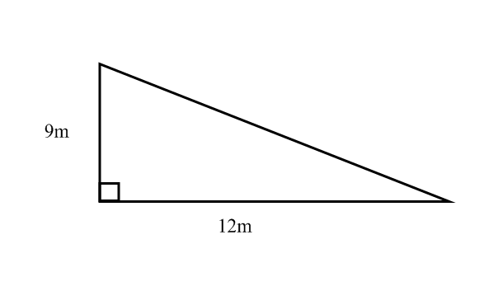18. A small triangular garden is to be fenced in, how many metres of fencing is required?

19. The factors of each number are listed in ascending order. Which numbers are square numbers? If it is a square number state the square root.

a) **225:** 1, 3, 5, 9, 15, 25, 45, 75, 225

c) **120:** 1, 2, 3, 4, 5, 6, 8, 10, 12, 15, 20, 24, 30, 40, 60, 120