**Grade Eight Review for Final – Unit 2**

**Multiple Choice Section**

1. Which multiplication statement represents the following addition statement?

(- 3) + (- 3) + (- 3) + (- 3)+(- 3)

A. 5 x 3 B. -5 x (+3) C. (-3) x 5 D. (-3) x (- 5)

1. Determine - 5 x (- 10) x (- 2).

A. – 100 B. – 50 C. 50 D. 100

1. A stock market decreased in price by $200 over 4 days. Determine the mean daily decrease.

A. - 4$/day B. -50/$day C. -100/$day D. -800/$day

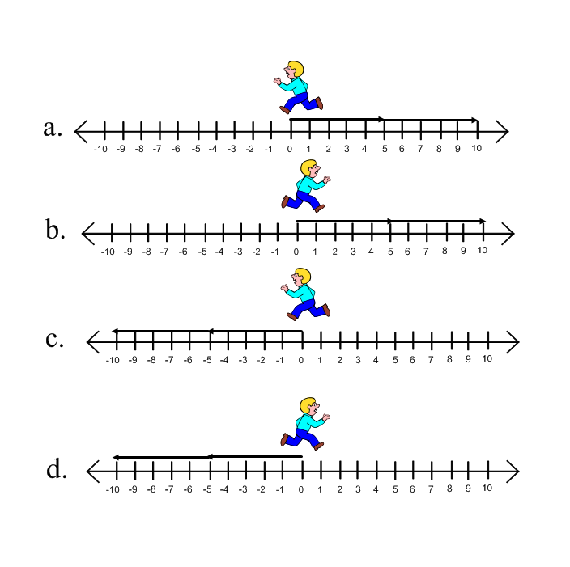

1. Which model represents (- 2) x (-5)?

**5.** Which situation could be represented by the division problem?

A) The temperature dropped 24oC per hour for six hours.

B) The temperature dropped a total of 24oC over a six hour period.

C) The temperature increased 24oC over a six hour period.

D) The temperature increased 24oC per hour for six hours.

6. Calculate: 

A) - 13 B) - 1 C) +1 D) +13

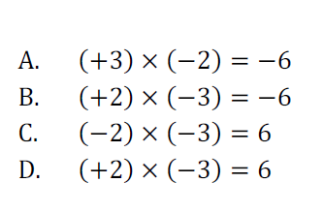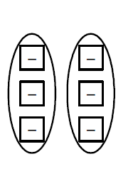7. What product is represented in the diagram?

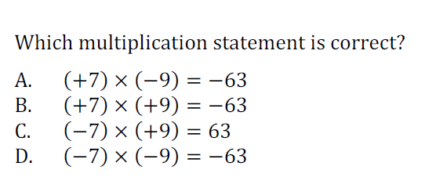

8.

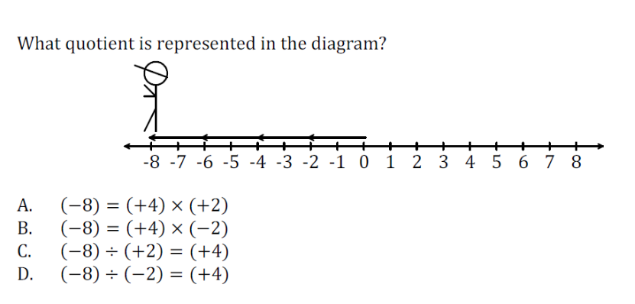

9.

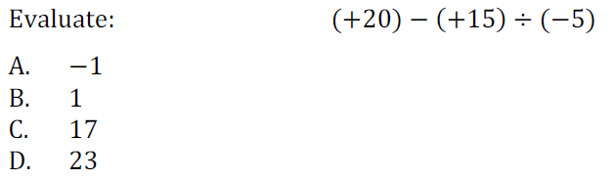10.

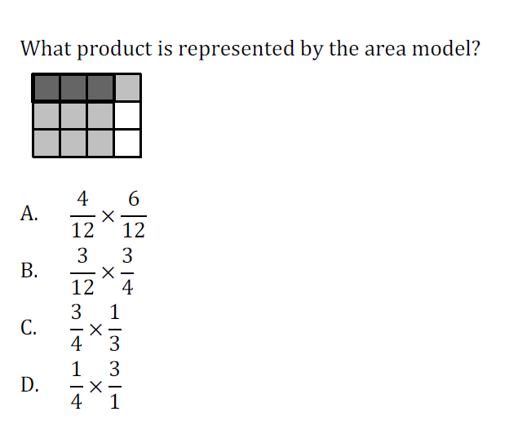11.

**Long Answer Section**

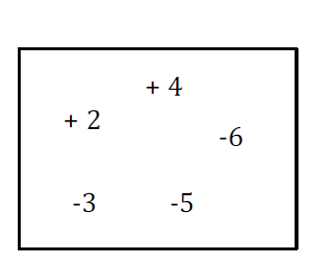12. Name all the pairs of integers that have a positive product.

13. Model using the model of your choice.

14. Calculate each quotient.

A) _________ B) _________ C) _________

15. Three months ago, Sean had $642 in his bank account. For the past three months, he spent $24 per month on his golf membership, while his aunt deposited $35 per month in his account. What is Sean’s current account balance?