**Grade Eight Review for Final – Unit 4**

**Multiple Choice Section**

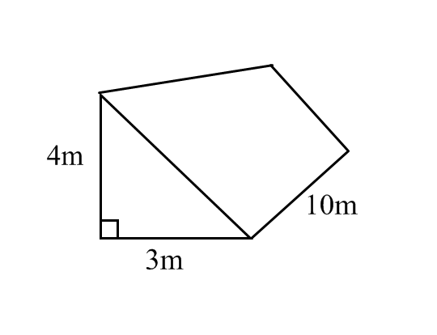

1. What is the volume of this prism?

A) 60 m3

B) 60 m2

C) 120 m3

D) 120 m2

2. Find the volume.

*8 m*

*6 m*

*12 m*

A) 288 

B) 480 

C) 576 

D) 720 

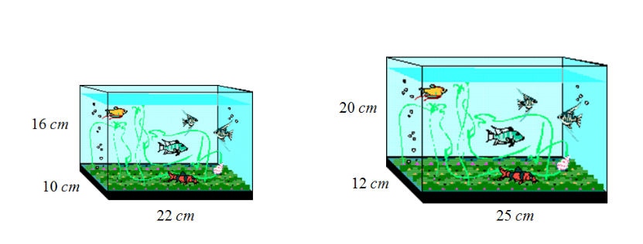

3. Seth wants to move his goldfish into a larger tank. The tanks are pictured below.

Assuming both tanks are filled to the top how many more *ml* of water will the new tank hold compared to the old tank?

A) 2480 *ml*  B) 3520 *ml*

C) 6000 *ml*  D) 9520 *ml*

4. Determine the total surface area of the cylinder.

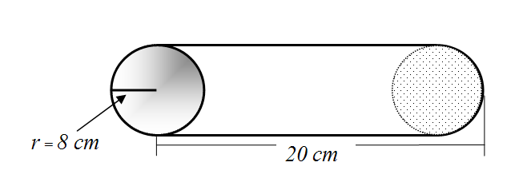

A) 1004.8 

B) 1205.8 

C) 1406.7 

D) 4019.2 

5. This wooden shadow box, with no front, has the dimensions indicated (10 cm on each edge). How many square centimeters of decorative paper are needed to cover *the 5 outer sides* of this box?



A) 150

B) 500

C) 600

D) 1000

6. A contractor needs to fill a cylindrical hole in the ground. If he knows the depth and the width of the hole, what formula would he use to calculate the amount of fill that he needs?

A)  B)   C)   D) 

7. What is the total surface area of this cylinder?



(A) 904.32 cm2

(B) 942.0 cm2

(C) 1130.4 cm2

(D) 2712.96 cm2

8. What is the volume of this prism?



(A) 224 cm3

(B) 560 cm3

(C) 1120 cm3

(D) 2240 cm3

LONG ANSWER SECTION

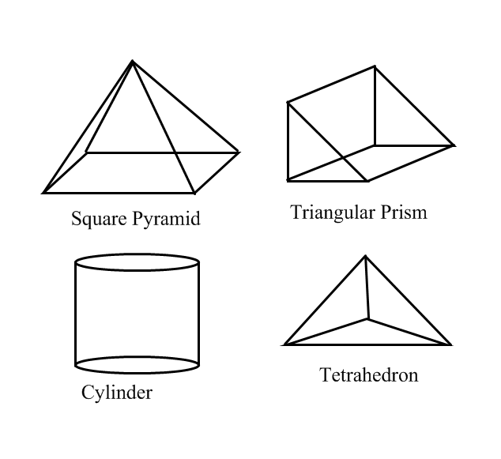9. Draw nets for the following objects and tell how many triangles, rectangles and squares the nets have.

10. An oversized soup can has a height of 20 cm. The ***area of the base*** is 100 cm2.

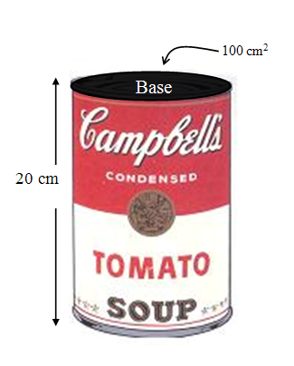

What is the volume of the can, measured in cm3?

11. Determine the surface area of this prism.



12. The hollow glass tubing used in science labs comes in different sizes. A common size has an outer diameter of 8 mm and an inner diameter of 5.8 mm. What is the volume of glass in a 120 mm length of this tubing?

